How we use PCA for dimensionality reduction:

Since earlier we see that eigen vector (V1) is the dimension at which we have maximum variance among all.

So for dimensionality reduction of 2-D into 1-D we will just project each xi on V1(eigen vector) to obtain new feature xi’ which is dot product of transponse of xi and V1 ie:

xi’ = xiT. V1

Why we are picking V1, because it has maximum variance.

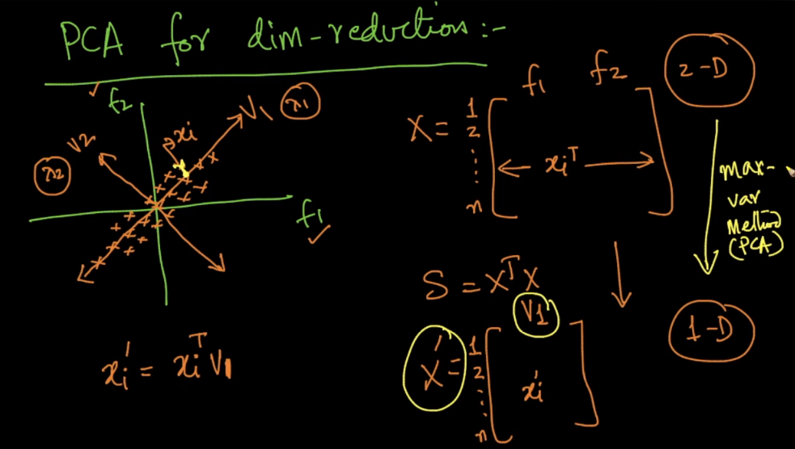

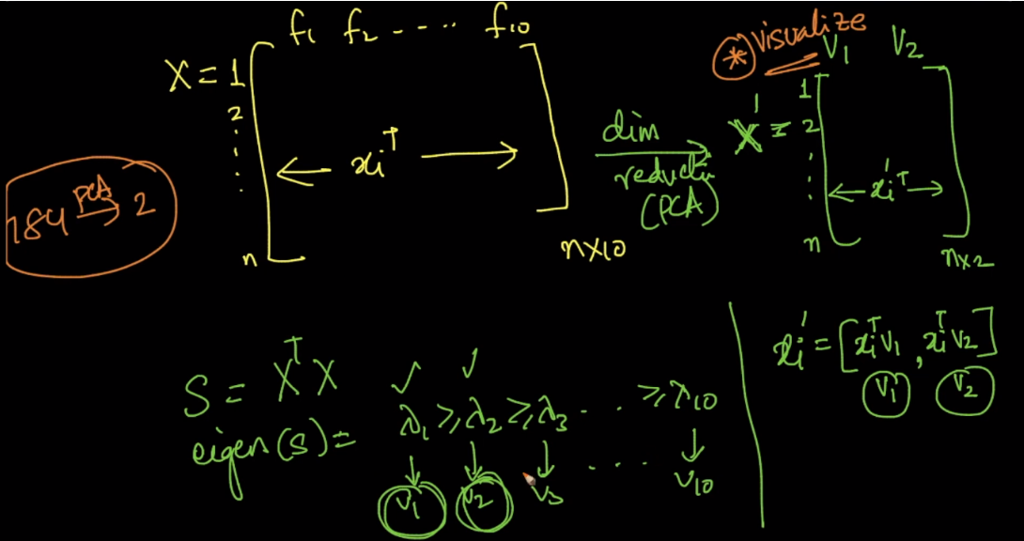

Now what if we have 100 D and want to convert it into 50 dimensions.

As for 2D to 1D we took V1, therefore for 100D to 50D, we will take V1, V2,…………., V50.

So any particular element in new data-matrix let’s say at ith row and jth column will be

Xij’ = xiT.Vj as it’s result is scalar.

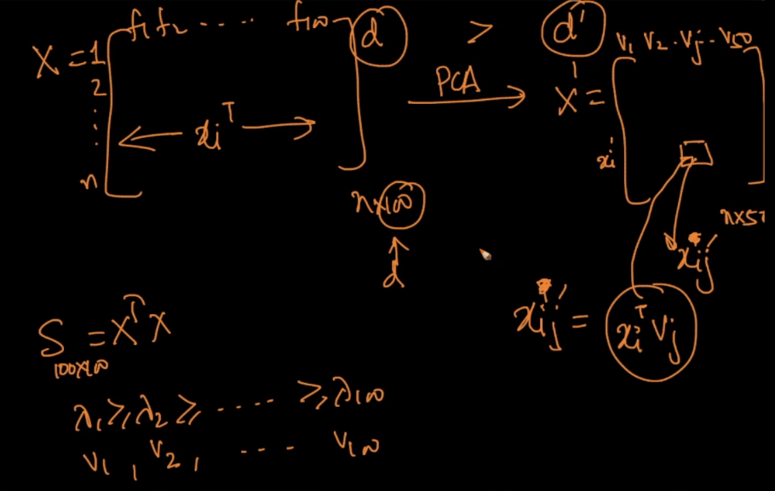we can also perform dimensionality reduction in a way as suppose we want 99% of the preservence of variance, now whether it will achieve with 50 V or 60 V, will choose that number of eigen vectors, who will preserve 99% of the variance.